LETS LEARN !!!

THOUGHTS BECOME THINGS

Variables:

Let used for all
Let object= //has key value pair
{

Name : ”afaf ”,
Id : 1,
isAdmin :false

};

console.log(object.name);

Print Function:

console.log();

Functions:

Function (a,b) //dont have to give data types of variables and function
{

}

Const functionname =(variables) =>{
Let x=1;
}

Const greet=() => a+b; //the return keyword not needed

//“Hey, don’t let this variable (greet) get reassigned to something else.” thats what constant doing

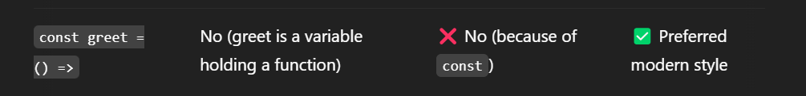

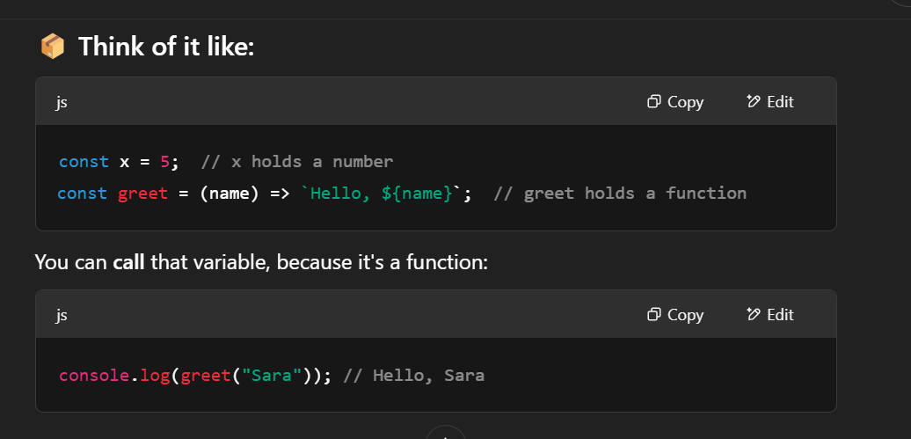

COOL JAVASCRIPT:

Using Helper functions:

const utils = {
add: (a, b) => a + b,
greet: (name) => `Hi, ${name}`,
};

console.log(utils.add(2, 3)); // 5
console.log(utils.greet("Ali")); // Hi, Ali

Using helper functions in an array : actions[0][1]

const sayHi = () => "Hi!";
const sayBye = () => "Bye!";

const actions = [sayHi, sayBye];
const random = Math.floor(Math.random() * 2);

console.log(actions[random]()); // Either "Hi!" or "Bye!"

Passing Another Function Inside Another Function:

const greet = (name) => `Hello, ${name}`;

const callFunction = (fn, value) => {
console.log(fn(value));
};

callFunction(greet, "Ali"); // Output: Hello, Ali

PROMISES:



ASYNC/WAIT

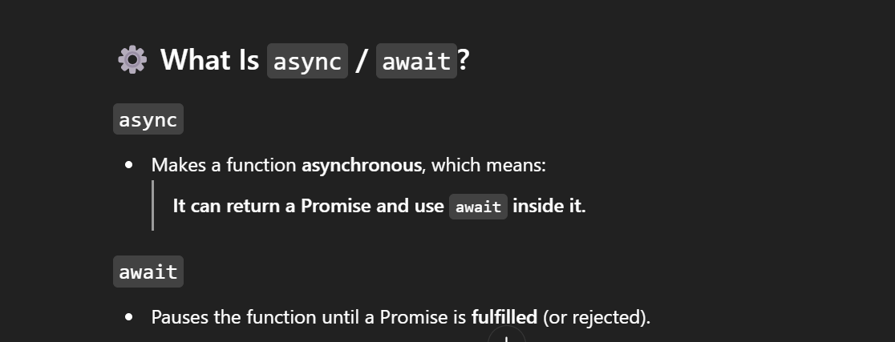

CODE:

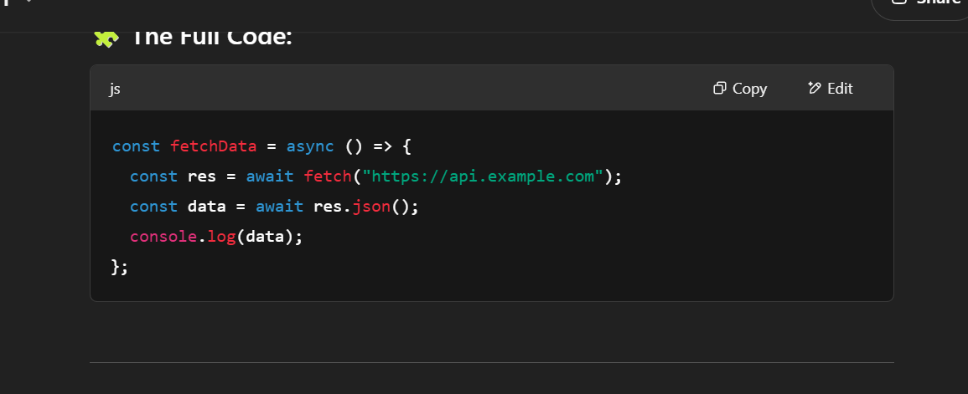

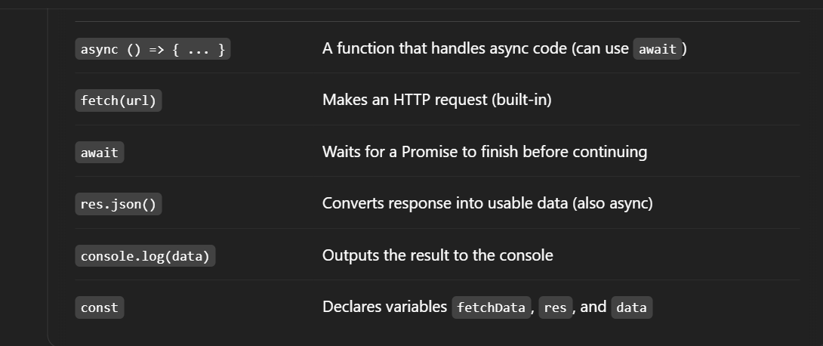

HOW TO HANDLE SYNCRONOUS AND ASYNCHRONOYS TASKS:



How backend and frontend use it 👍

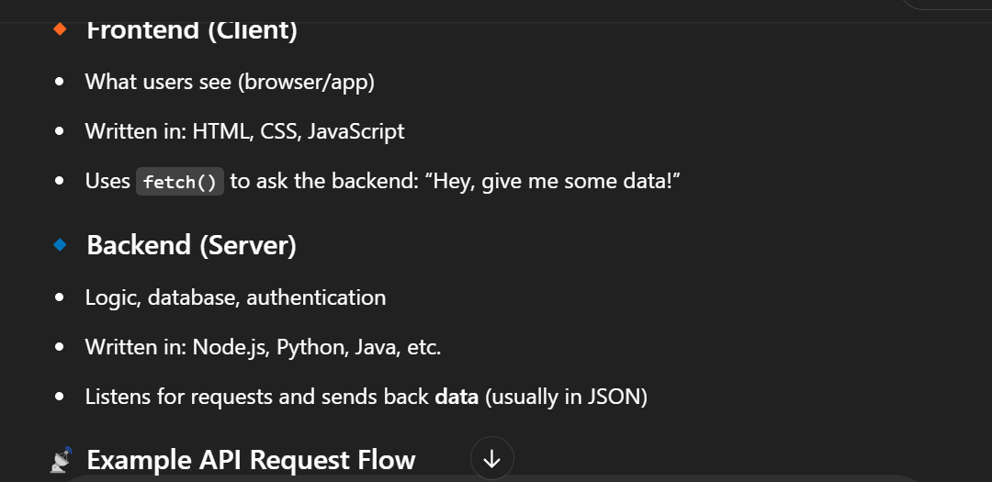

IMPORT AND EPORT IN JS USE :

